**A REPORT OF SIX WEEKS INDUSTRIAL TRAINING**

**at**

**SIMULANIS SOLUTIONS**

SUBMITTED IN PARTIAL FULFILLMENT OF THE REQUIREMENT FOR THE AWARD OF THE DEGREE OF

**BACHELOR OF ENGINEERING**

**IN**

**COMPUTER SCIENCE & ENGINEERING**



MAY-JUNE, 2019

**Submitted By:**

UTKARSH YADAV

UID: 17BCS1231

**DEPARTMENT OF COMPUTER SCIENCE & ENGINEERING**

CHANDIGARH UNIVERSITY GHARUAN, MOHALI

**CANDIDATE'S DECLARATION**

I, Utkarsh Yadav, hereby declare that I have undertaken six weeks industrial training at “Simulanis Solutions Pvt Ltd” during a period from 15th May 2019 to 25th June 2019 in partial fulfillment of requirements for the award of degree of B.E (COMPUTER SCIENCE & ENGINEERING) at CHANDIGARH UNIVERSITY GHARUAN, MOHALI. The work which is being presented in the training report submitted to Department of Computer Science & Engineering at CHANDIGARH UNIVERSITY GHARUAN, MOHALI is an authentic record of training work.

Signature of the Student

 The six weeks industrial training Viva–Voce Examination of__________________ has been held on ____________ and accepted.

 Signature of Internal Examiner Signature of External Examiner

**ABSTRACT**

Augmented reality (AR) is a type of interactive, reality-based display environment that takes the capabilities of computer generated display, sound, text and effects to enhance the user's real-world experience. Augmented reality (AR) is a live direct or indirect view of a physical, real-world environment whose elements are "augmented" by computer-generated or extracted real-world sensory input such as sound, video, graphics or GPS data. In Augmented Reality the real view is modified by a computer (Smartphone in this case). Augmented reality (AR) enhances one’s current perception of reality, whereas in contrast, virtual reality replaces the real world with a simulated one. Augmentation techniques are basically performed in real time. Example: Displaying live scores and statistics inside a live video of a sporting event.

Augmented reality combines real and computer-based scenes and images to deliver a unified but enhanced view of the world. Augmented reality has many different implementation models and applications, but its primary objective is to provide a rich audiovisual experience. AR works by employing computerized simulation and techniques such as image and speech recognition, animation, head-mounted and hand-held devices and powered display environments to add a virtual display on top of real images and surroundings.

**ACKNOWLEDGEMENT**

I would like to express my gratitude to my mentor, his expertise and understanding, added considerably to my graduate experience this semester. I would also like to thank my family for their support and my friends, with whom I had a lot of fun during this training while working on project. The help rendered by Mr Gaurav Sharma during project sessions for experimentation is greatly acknowledged.

Finally, I express my indebtedness to all who have directly or indirectly contributed to the successful completion of my Augmented Reality project

Utkarsh Yadav

**About the Company**

* Simulanis Solutions started back in 2013, and have seen the evolution of  AR-VR-MR technologies over the past 5 years, whilst ensuring that we are at the cutting-edge of it.
* We specialize in simulating immersive content for a wide range of industries, education, skilling, and training sectors such as Pharmaceutical, Automotive, Oil & Gas etc. by following a strict pedagogical approach. Our core focus is on revolutionizing the existing training methods by cutting down the costs of training and making the training programs more
* Simulanis Solutions provide extensive training to students in Augmented Reality.

Simulanis Solutions is demonstrating its footfall in education industry by introducing augmented reality in education business helping audience to overcome from old teaching and reading tactics with interactive and engaging learning material. Augmented reality in education offers learners to get more interactive and appealing material with more interesting content in term of videos, images, animations etc,. which is able to grab the attention of learners across the academic levels with more knowledge & higher retention. Creating curiosity in education industry with augmented reality can be a big game changer for both academicians and learners to immense their knowledge with less boring stuff of current education system. Introducing augmented reality in education system is serving education industry to invest less in training materials and equipments by adopting AR in place. By adopting augmented reality in education an academician can take the industry advancement altogether can achieve the higher results with more potential while attracting new learners towards their academic institutes. Implementing augmented reality in education in early stage can be industry advantage while targeting to achieve further academic goals.

**List of Figures**

|  |  |  |
| --- | --- | --- |
| **Figure No.** | **Title** | **Page No.** |
| 1.1 | AR versus VR | 2 |
| 1.2 | MR , AR and VR | 4 |
| 3.1 | Barbarian Model | .11 |
| 3.2 | Ground Plane Layer | 12 |
| 3.3 | Antman on Ground Plane | 12 |
| 3.4 | Ground Plane Surface | 13 |
| 3.5 | Ground Plane Code Implementation | 13 |
| 3.6 | Floorplan | 14 |
| 3.7 | Architecture Plan | 15 |
| 3.8 | AR Business Card | 15 |
| 3.9 | AR Virtual Button | 16 |
|  |  |  |

**CONTENTS**

**Topic Page No.**

***Certificate by Institute i***

***Candidate’s Declaration ii***

***Abstract iii***

***Acknowledgement vi***

***About the Company/ Industry / Institute v***

***List of Figures vi***

**CHAPTER 1** **INTRODUCTION 1-4**

**1.**1 Augmented Reality 1

**1.2** AR and VR 2

**1.3** Vuforia 3-4

**CHAPTER 2 TRAINING WORK UNDERTAKEN 5-15**

2.1 Basics of Unity 5-6

2.2 Features 7-10

2.3 SDKs 11-12

2.4 AR apps 12-13

2.5 Intended Audience 14-15

**CHAPTER 3 RESULTS AND DISCUSSION 16-22**

**3.1** Image target Detection 16-17

**3.2** Ground Plane Detection 17-19

**3.3** Architecture Plan 20-21

**3.4** AR Business Card 22

**CHAPTER 4 CONCLUSION AND FUTURE SCOPE 23-25**

**4.1** Conclusion 23

**4.2** Future Scope 24

**REFERENCES** 25

**CHAPTER 1: INTRODUCTION**

**1.1 Introduction to Augmented Reality**

## What is Augmented Reality?

## According to Wikipedia, Augmented reality (AR) is a live direct or indirect view of a physical, real-world environment whose elements are "augmented" by computer-generated or extracted real-world sensory input such as sound, video, graphics or GPS data.

## In Augmented Reality the real view is modified by a computer (Smartphone in this case). Augmented reality (AR) enhances one’s current perception of reality, whereas in contrast, virtual reality replaces the real world with a simulated one. Augmentation techniques are basically performed in real time,

## Eg : Displaying live scores and statistics inside a live video of a sporting event

## Power of Augmented Reality

## There are different Augmented Reality platform. Vuforia platform seemed very promising as developers all over the World have used Vuforia for developing Augmented Reality apps.

## Pokemon Go game is the best example of Augmented Reality. Other than that Augmented Reality apps expand over a wide range of topics from Education, Business, Architecture, Health Industry, Home Decoration and obviously mobile gaming.

## Unity is the main software which we will use for building Augmented Reality apps.

## Augmented reality (AR) is a type of interactive, reality-based display environment that takes the capabilities of computer generated display, sound, text and effects to enhance the user's real-world experience.

## Augmented reality combines real and computer-based scenes and images to deliver a unified enhanced view of the world.

## Augmented reality has many different implementation models and applications, but its primary objective is to provide a rich audiovisual experience. AR works by employing computerized simulation and techniques such as image and speech recognition, animation, head-mounted and hand-held devices and powered display environments to add a virtual display on top of real images and surroundings.

**1.2 Related Technologies**

## Virtual Reality vs Augmented Reality

Augmented reality and virtual reality are two of the ways that tech can change the way you look at the world. The terms can be confusing. Sometimes people think AR and VR are the same thing.

Augmented reality and virtual reality are increasingly used in technology, so knowing the difference is important.

## Virtual reality (VR) is a three-dimensional virtual environment that uses VR “goggles” or glasses to mimic reality as closely as possible.

## Augmented reality (AR), a related technology, enhances (or augments) reality by providing digital information on top of what the user is seeing, allowing learners to practice skills and understand the outcomes of their actions in a simulated environment.

This picture helps explain the difference between the two.

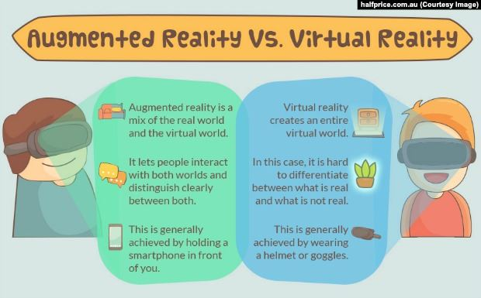

Figure 1.1

Augmented reality is defined as "an enhanced version of reality created by the use of technology to add digital information on an image of something."

AR is used in apps for smartphones and tablets. AR apps use your phone's camera to show you a view of the real world in front of you, then put a layer of information, including text and/or images, on top of that view. Apps can use AR for fun, such as the game Pokémon GO.

The AR app can show you interesting information about places you visit, using augmented reality. Open the app when you are visiting a site and read information that appears in a layer over your view. We can also find money machines, see real estate for sale, find restaurants, and more using the AR feature of the app. You may even discover new sites you did not know existed.

## 

## Virtual Reality

* Virtual Reality is defined as "the use of computer technology to create a simulated environment."
* When you view VR, you are viewing a completely different reality than the one in front of you.
* Virtual reality may be artificial, such as an animated scene, or an actual place that has been photographed and included in a virtual reality app.
* With virtual reality, you can move around and look in every direction -- up, down, sideways and behind you, as if you were physically there.
* You can view virtual reality through a special VR viewer, such as the Oculus Rift. Other virtual reality viewers use your phone and VR apps, such as Google Cardboard or Daydream View.
* With virtual reality apps, you can explore places you have never been, such as the surface of Mars, the top of Mt. Everest, or areas deep under the sea. The New York Times has a virtual reality app that lets you experience virtual environments on Earth and other planets.
* Google Earth also has a virtual reality app.

**1.3 DIFFERENCE BETWEEN AR, VR, AND MR**

* **Augmented reality (AR)** adds digital elements to a live view often by using the camera on a smartphone. Examples of augmented reality experiences include Snapchat lenses and the game Pokemon Go. Augmented reality (AR) overlays virtual objects on the real-world environment.
* **Virtual reality (VR)** implies a complete immersion experience that shuts out the physical world. Using VR devices such as HTC Vive, Oculus Rift or Google Cardboard, users can be transported into a number of real-world and imagined environments such as the middle of a squawking penguin colony or even the back of a dragon. Virtual reality (VR) immerses users in a fully artificial digital environment.
* **Mixed reality (MR)** experience, which combines elements of both AR and VR, real-world and digital objects interact. Mixed reality technology is just now starting to take off with Microsoft’s HoloLens one of the most notable early mixed reality apparatuses. Mixed reality (MR) not just overlays but anchors virtual objects to the real world.

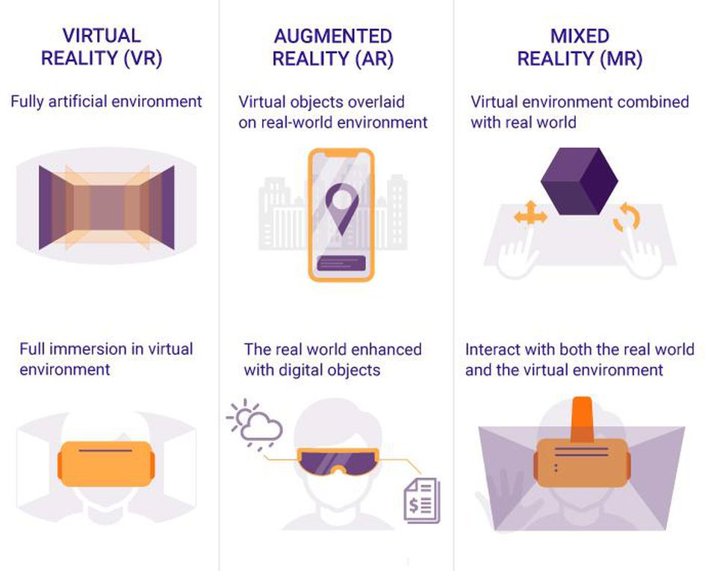

Figure 1.2

**CHAPTER 2: TRAINING WORK UNDERTAKEN**

**2.1 Basics of Unity:**

**2.1.1 Objective**

Unity is the main software which we will use for building Augmented Reality apps.

The primary objective is to create 'Real World' augmented reality applications, mixed reality apps that can be used to boost sales by impressing the client, they will have to share your apps with everyone they know.

A common trend with AR courses is to demonstrate the technology by creating simple mini apps, projecting a 3D model on a surface in front of the user; this is usually done with an image target or possibly a ground plane. Although this is 'cool' as it doesn't capitalize on the marketing power AR offers. Using AR we will break this trend by creating beautiful apps fit for commercial demonstration to potential customers.

In Augmented Reality, we learn by doing (plus a few scripts we may give you as time savers). Together, we use the latest versions of Unity (upgrading to 2018 mid way), Vuforia and the online AI bot. No additional things in AR apps are required along the way and all materials are provided. Beginners to this technology and computer programming are more than welcome to Augmented Reality by the current users in the corporate world.

**2.1.2 Intended Audience**

* Here AR is intended for several audiences, including the customer, as well as Computer programming students interested in C# programming for building Augmented Reality applications
* Unity Developers interested in Augmented Reality platforms
* Anyone who wants to develop their own AR Applications.

**2.1.3 Scope**

Augmented Reality apps expand over a wide range of topics from Education, Business, Architecture, Health Industry, Home Decoration and obviously mobile gaming.

**2.2 Features**

**2.2.1 With AR we can learn how to program and work with:**

• iOS

• Android

• Wikitude SDK

• 2D Image Recognition and Tracking

• 3D Object Recognition and Tracking

• Shadows, Lights and Occlusion shaders for AR

• Mobile GPS & Compass functions

• Physics in AR

• Simultaneous Localisation and Mapping (SLAM).

**2.2.2 AR Features:**

• User Defined Image targets

• Image Tracker Projects

• Handling Multiple Trackers

• Mid-Air Plane Detection

• Markerless Tracking

• Mobile GPS & Compass functions

• Hiding and Showing Augmented Objects

• Motion Tracker

• Music Rendering

• Video Rendering

**2.3 Requirements**

* An interest in Augmented Reality
* An interest in machine learning / AI bots
* An interest in learning Unity 3D
* A microphone (Laptop or USB) | Possible alternate setup Android Only, an app (IP cam) on Android and any camera on PC

**2.4 Augmented Reality Apps**

**2.3.1 Augmented Reality One (ARONE) application**

1. Download and Setup Unity in your pc.
2. Create Vuforia account
3. Create License Key for the AR app
4. Upload an Image as Image Target
5. Rating must be above 3 i.e., image must be rich in quality features
6. Understand Vuforia Image Recognition system
7. Solution to White Image Target problem in Vuforia version 6.2.10
8. Download 3D model from Unity Asset Store
9. Place 3D Model on top of Image Target
10. Download ARONE app database from Vuforia and activate it inside Unity
11. Build this app for Android & IOS.

**2.3.2 Augmented Reality Book (ARBOOK) application**

In the AR Book application we will first create few sketches inches a drawing book. Next we will download some 3D Models from the asset store and project the 3D Model on top of each image target.

Application like AR BOOK can be implemented in Schools & Colleges for teaching complicated subjects in a fun and easier way.

**2.3.3 Virtual Button & Augmented Reality Business Card (AR Business Card)**

In this section we will come to know the concept of Virtual Button in Vuforia and the six important factors that should be considered while working with Virtual Button.

1. Next we will create a simple Virtual Button app called Augmented Reality Virtual Button in which we will understand the important function & interface that are required for working with Virtual Button.
2. After the AR Virtual Button app we will then create and AR Business Card.
3. In the AR Business Card app we will first place multiple virtual buttons on top of an Image Target.
4. Next we will come to know how to play video file inside Unity.
5. After this we will write a C# script to play a particular video when the virtual button for a particular video is pressed

**2.3.4 Augmented Reality Greeting Card**

In this section, you will learn the process of detecting multiple image targets simultaneously at the same time. You will also add an mp3 file in the app that will start playing only when the greeting card is opened.

**2.3.5 Superimposition based AR | Object tracking –**

In this section we will first scan a 3D model using Vuforia’s 3D scanning android application. Next we will import this model inside Unity and on top of this model we will superimpose a digital car.

**2.3.6 Cylindrical Object tracking**

In this section we will learn the technique for detecting a cylindrical object. After detecting the cylindrical object we will create a beautiful 3D scenic view around the cylinder with the help of airplanes, low poly clouds and low poly terrains.

**2.3.7 Vuforia Cloud Recognition**

In this section we will understand the working of Vuforia cloud databases. We will create an application called BookInfoAR. This application will scan a book cover(marker) and display information panel beside the book cover. The information of the marker is stored in cloud database.

**2.3.8 Ground Planes and Mid-Air**

In this section we will create our first markerless augmented reality app using Vuforia Ground Plane. With ground plane feature we can place a lifesize Lamborghini model in real world. Next using the MidAir feature we will place a drone in mid air.

**2.3.9 User Defined Target**

In this section you will understand a feature called User Defined Target feature from the Vuforia Core Sample. With the help of User Defined Target feature we can use any image as an marker.

**2.5 Other SDKs for Augmented Reality**

**If we ever wanted to build a crazy Augmented Reality app and learn at the same time we can build cross platform AR apps.**

By using Augmented Reality, we can build our own private Instagram AR Portal Room that shows our top 5 Instagram pictures. We may learn to build cross platform AR apps that run ARCore and ARKit at the same time. It is possible due to AR Foundation.

AR Foundation is a multi-platform API that allows us to develop cross platform AR apps. With AR Foundation, we develop once and build to both Android and IOS saving our time and energy.

This AR could be built with the latest Unity version which is Unity 2018.3.

**Using Augmented Reality here, we will learn lots of different things and combine them into a beautiful AR app:**

* In this first section, we will get started with AR Foundation and build a simple AR Foundation app which is Hello AR.
* In the second section, we will get started with Shader coding using Unity's Shader Lab and write our own Shader to get a portal effect. Then, we will write Portal script from scratch. This script will get us into the Portal. Then, we will integrate AR Foundation into our project and build two apps; one that runs ARCore and one that runs ARKit. After that, we will write Portal Placer and Plane Controller scripts from scratch. These scripts are fundamental scripts that should be used by other AR Apps as well.
* In the third section, we will get started with Instagram API and we will integrate Instagram API into Unity. Then, we will get your most liked 5 Instagram pictures by comparing the likes count of each Instagram picture. After that, we will show your TOP Five Instagram picture inside our Portal Room along with your profile picture and username.

So, this will teach not only Augmented Reality but also working with APIs and Shaders inside Unity 2018.3. We will code on our own Shader, parse JSON, download pictures, write fundamental AR scripts... All of them will be done from scratch.

**2.6 What can be made:**

* Understand different forms of Augmented Reality and their applications
* Build Augmented Reality Apps from scratch for Android & iOS
* Developing an AR Book app which will detect multiple image targets.
* Creating an interactive business card using AR Virtual buttons
* An AR greeting card app, which plays sound, and animation once opened.
* Detecting a real toy car using 3D Object tracking and superimposing a digital car on top of the real car.
* Tracking of cylindrical objects and placing digital models surrounding the cylinder
* Placing a life size Lamborghini car in real world using Marker less tracking
* Placing a life size drone in air using Vuforia Mid Air feature.
* Play / Pause video's in real world.

**Chapter 3: RESULTS AND DISCUSSIONS**

**3.1 Animated 3D model in Augmented Reality :**

This application basically scans the image target surface and projects the animated 3d model on the top of it. This application is implemented in Snap Chat filters and other Camera applications in mobile phones

This application works on the principle of image target detection and implemented in Augmented Reality. Here the mobile applications scans the image target and recognizes the image if it is rich in features that means if it has a lot of features that could be pointed out easily and this can be measured by checking the rating of that image in Vuforia. Also, if it is more than three stars then the image target is good and could be detected easily otherwise we have to change the image target again in Vuforia Developers portal.

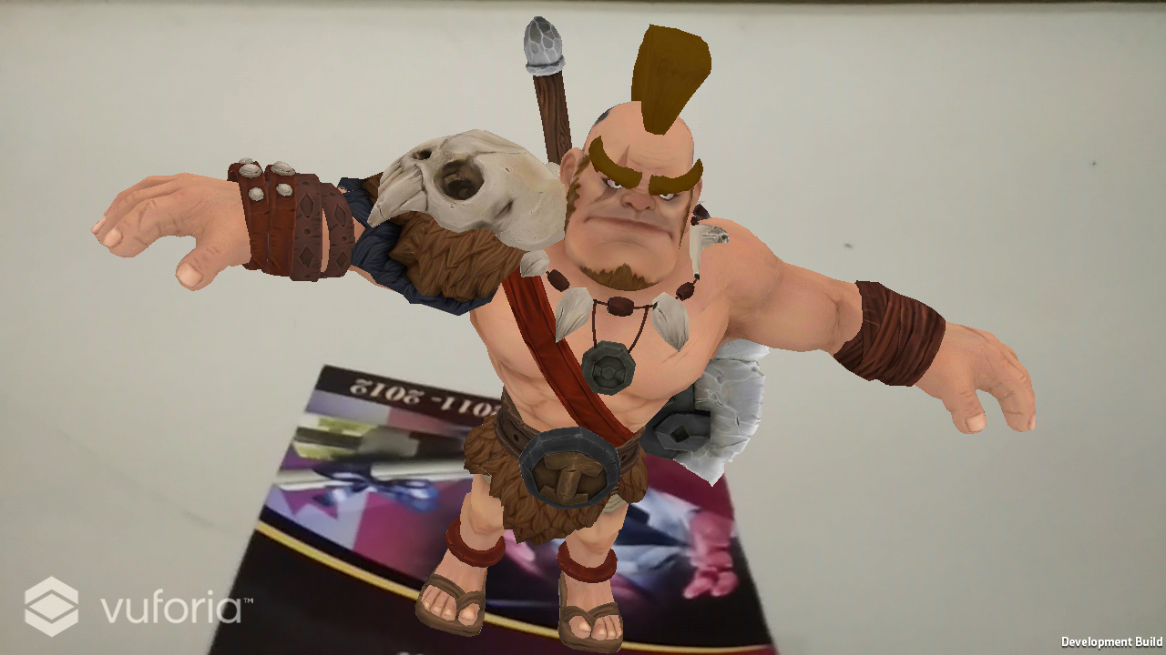

Figure 3.1 Barbarian Model

**3.2 Ground Plane Detection through AR Application :**

Ground plane detection is a feature provided by Vuforia in which the application detects the plane surface. The application when detects a plane surface thereby it projects the augmented 3d model on the top of the plane surface. We need to scale our 3d model according to our visual requirements. We also need to disable the duplicity of 3d model which occurs on tapping over the screen.

By using the script we also added the scaling option on the 3d model using the finger touch gesture and a canvas is also added for the buttons which controls the character.

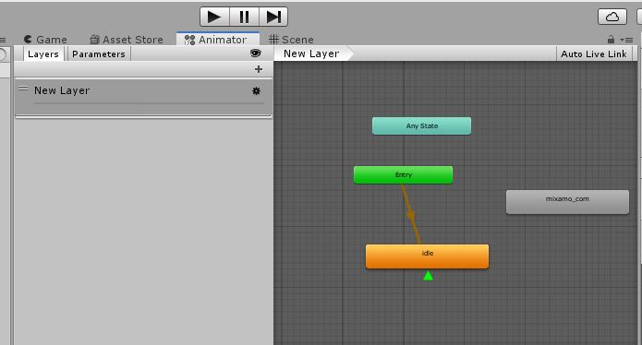

Figure 3.2 Ground Plane Layer

By using the script we also added the scaling option on the 3d model using the finger touch gesture and a canvas is also added for the buttons which controls the character.

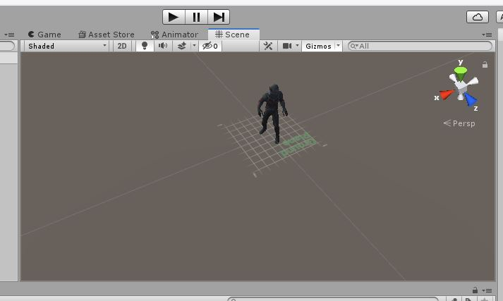

Figure 3.3 Antman on Ground Plane

There are two buttons ‘Dance’ and ‘Reset’ on the bottom of the mobile screen. The Dance button is used to animate the character and simultaneously plays the music in the background. On the other hand, the Reset button on the bottom of the screen is for resetting the model to its original position.

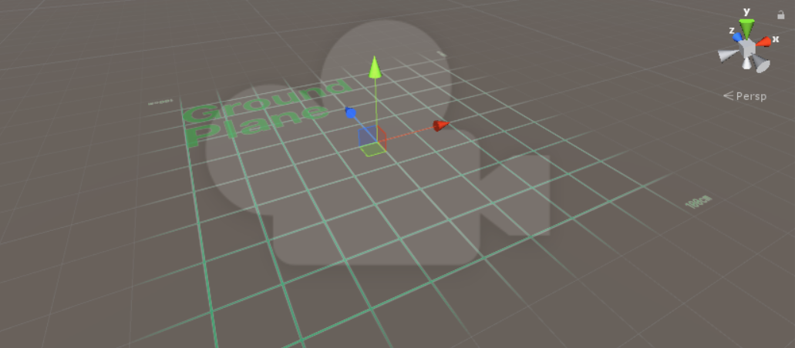

Figure 3.4 Ground Plane Surface

All the coding was done in C# and the project was made on unity using the Vuforia SDK.

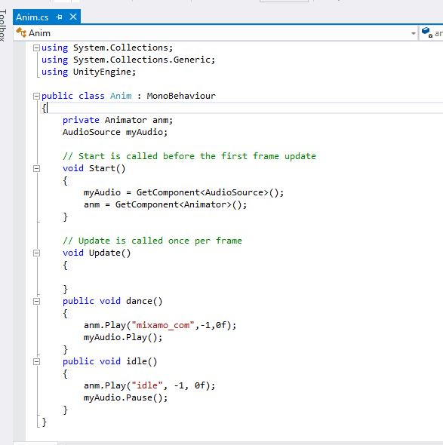

Figure 3.5 Ground Plane Code Implementation

**3.3 Architectural plan through Augmented Reality:**

This application basically scans the architectural plan of the houses and projects the 3d model on the top of it. This application is very helpful for the civil engineers or the home designers because now they can see the model in a 3d representation.

It could be a bit difficult to imagine a 2d plan in 3d but this application gives user a relief because the 3d model can be viewed in reality.

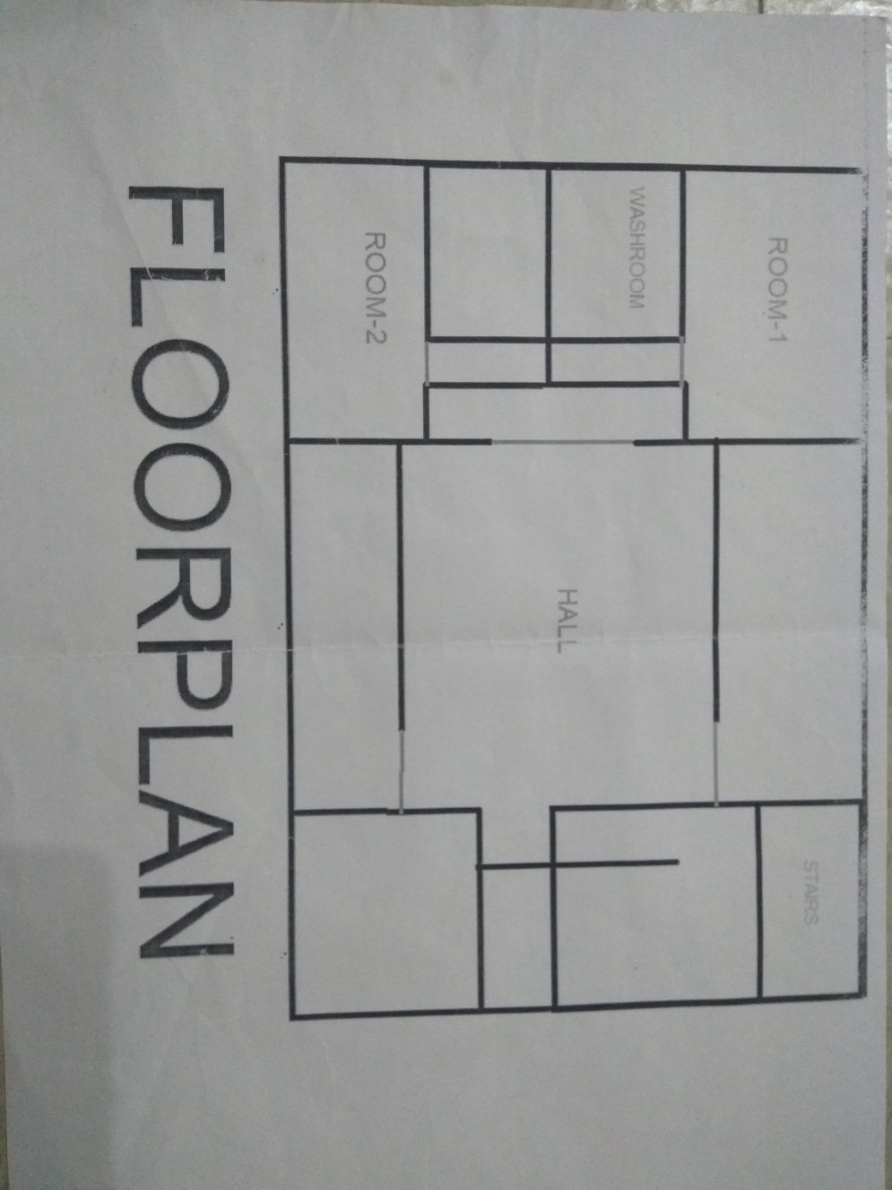

Figure 3.6 Floorplan

This application works on the principle of image target detection and it is an example of Markerless Augmented reality. Here the applications scans the image and recognizes the image if it is rich in features that means if it has a lot of features that could be pointed out easily and this can be measured by checking the rating of that image in Vuforia. Also, if it is more than three stars then the image target is good and could be detected easily otherwise we have to change the image target again in Vuforia developers portal.

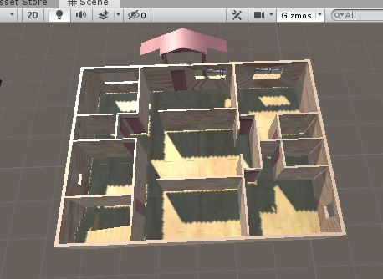

Figure 3.7 Architecture Plan

**3.4 AR Business Card using Augmented Reality :**

AR Business Card is becoming very popular nowadays because people are more active on social media. And the main problem with the traditional business card is that people don’t remember their username for their particular social media accounts. With the help of AR Business Card people now can visit the other person’s social media account by just scanning the business card and projecting the buttons over it so that user can click over it according to their own choice to visit the other persons account.

AR business card works by using Marker Detection technology. Markers are basically signs that a device recognizes and projects objects over it when you view it in AR. This is not standalone, you need to have a business card with a marker and a device with an app that recognizes that marker. It could be your company logo, a QR Code, or any other shapes that may be deemed special to be a marker.



Figure 3.8 AR Business Card

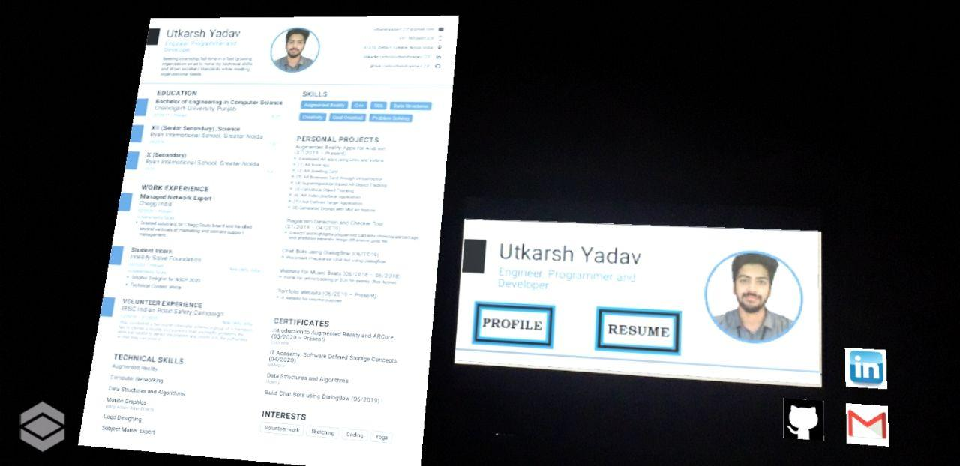

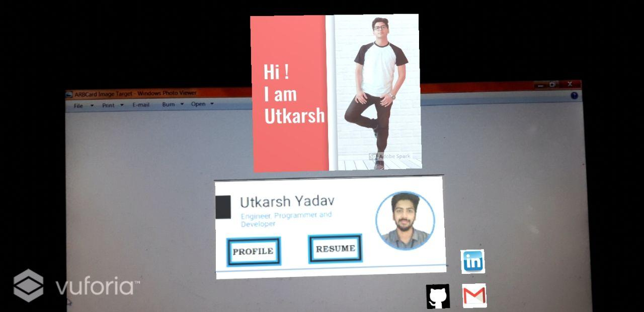

Figure 3.9 AR Virtual Button

There are certain scripts coded in C# and added to the planes to give the animation to it. These scripts basically control the rotation, scaling and transformation of the planes.

The technology of adding a virtual button is also added to it. So whenever the user hover on that button it triggers the particular action.

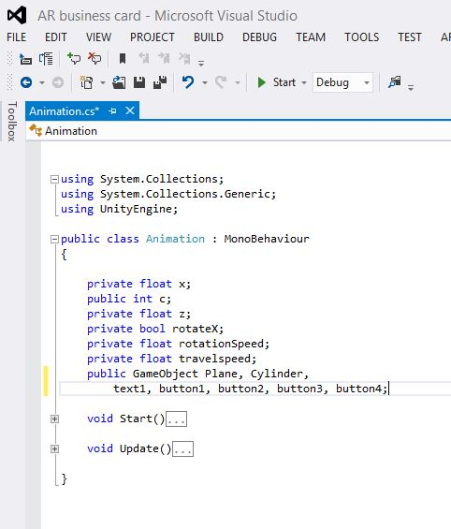

Figure 3.10 AR Animation Coding Implementation

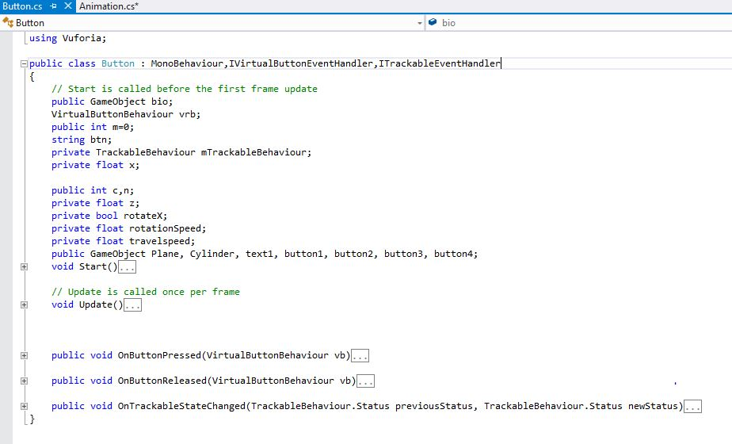

Figure 3.11 AR Button Coding Implementation

**Chapter 6: Conclusion**

From different ways of researching and analysing, most of the data and information convince that AR technology is applicable not only on architecture industry, but also sectors that relating to architecture and design such as construction and visualisation. With AR being rather new and innovative in every aspect, we have done a general research on AR technology. This has allowed us to collect more information about AR before we focus down our aims and objectives. Simultaneously, these researches also help supporting our studio projects as we get to know what can AR achieve in every aspects.

Throughout our research, the results are merely positive towards AR application in architecture and design. To strengthen our hypothesis, we have conducted two different kind of primary researches. With interview, we were able to collect important opinion from the perspective of designers and architects. The speculations and sentiments of the experts has given us a more comprehensive information on an industrial point of view. On the other hand, from the data and speculation that we gathered in the survey, we are able to discover another side of the story, which is what the public speculates about AR technology. By analyzing both sides of data and information, we were able to come out for a conclusion that although changing the way we design is merely impossible for AR, it can certainly revamp our current design process into a more comprehensive and transparent process in terms of client and designer. Also, with result from the survey, we were able to perceive what people need and what they speculate about AR and implement the research into our studio project.

On the other hand, to further support our speculation on AR towards architecture and design, we have listed 3 different case studies which cover and support our hypothesis. With collaboration, we were able to discover how AR can be applied into actual project its impacts on the design process. Besides, the experience on ARkit have let us truly get in contact with AR and personally discover what AR can really do. While the case study has also proved the feasibility of AR in architectural environment and contexts. These case studies has provided us a solid and practical support for my hypothesis.

From all the research and analysis that we have done, it has already prove that Augmented Reality could enhance the way we design for people. It has proven that with the characteristic of AR, people could comprehend and appreciate design more thoroughly. Indeed with all the supporting resources and analysis, we have to state that AR can change the dynamic of design by  making the process more transparent and comprehensive between designer and the community involved.

# Future Scope

**Features of Augmented Business card:**

* **Overlays additional information:**

With traditional cards bounded to share some basic information like owner’s name, company’s logo, address, contact details, website and e-mail address, the AR business cards hold immense potential to share much about your company, your product ad product catalogue too. In essence, Augmented reality business cards can act as a small window to your business, exhibiting all that works in your best interest.

* **Saves cost and space:**

With Smart devices AR technology used for displaying digital elements of AR business cards, both space and cost are cut down along with enhanced transparency and wisdom. It eliminates the need for physical prototypes of almost everything from brochures to catalogues and much more.

* **Enhances communication**:

With features like’ click’ to connect, the communication between the firm and the target audience have narrowed down, increasing the chances of turning them into potential customers. An animated version of you yourself popping out and making a pitch can make a lot of difference for your own business.

* **Higher rate of market penetration:**

AR technology has already aflame much of attention owing to its uniqueness and simplicity, as an outcome of which one can expect a massive acceptance of [augmented reality visiting cards](https://yeppar.com/augmented-reality-print-media.html), helping the businesses to reach to large customer base.

* **Futuristic concept:**

AR technology is yet in its nascent stage, promising a perpetual growth and augmentation. The early adopters of this technology can take the benefit of antiquated passion centered across AR business card and beat the competitors.

Whether people select browsing manually through your websites or brochure or seek help from AR apps like Yeppar to go through the catalogues, websites by dint of AR business cards; still needs a time, to come to any conclusion.

All these quatities makes the AR business card very useful for the organisations to make them use this technology.

# REFERENCES

|  |  |
| --- | --- |
| [1] | T. Hoad and J. Zobel, " Methods for Identifying Versioned and Augmented Reality Documents," *Journal of the American*  *Society for Information Science and Technology,* vol. 54, no. 3, p. 203–215, 2003. |
| [2] | K. Monostori, A. Zaslavsky and H. Schmidt, "Document Overlap Detection System for Distributed Augmented Reality Digital Libraries,"  *Proceedings of the fifth ACM conference on Digital libraries,* p. 226–227, 2000. |
| [3] | A. Si, H. V. Leong and R. W. H. Lau, "CHECK: A Document Augmented Reality System," *SAC ’97: Proceedings of the*  *1997 ACM symposium on Applied computing,* p. 70–77, 1997. |
| [4] | C. Noah, H. Marcus, J. Nick, S. Cole, T. Tony and W.-D. Zach, " Augmented Reality," 17 March 2014. [Online]. Available: www.cs.carleton.edu/cs_comps/1314/dlibenno/final-results/arcomps.pdf. |